**Exp 01. Create a simple cloud software application and provide it as a service using any**

**Cloud Service Provider to demonstrate Software as a Service (SaaS).**

**Aim**

To create a simple Movie Ticket Booking cloud application using Zoho Creator and provide it as a service over the cloud to demonstrate the Software as a Service (SaaS) model.

**Procedure**

* **Login to Zoho Creator** – Open Zoho Creator and sign in using your Zoho account.
* **Start a New App** – Click on “Create New Application” and either pick a ready-made template or start fresh.
* **Build Forms & Reports** – Create forms to collect data (like user info, products, etc.) and reports to view or analyze that data.
* **Add Automation** – Use Deluge scripting to set rules, validations, and automatic notifications.
* **Control Access** – Define user roles and permissions so only the right people can view or edit certain parts.
* **Publish & Share** – Launch your app, get a shareable link, and let others use it online like a SaaS product.

**Output**

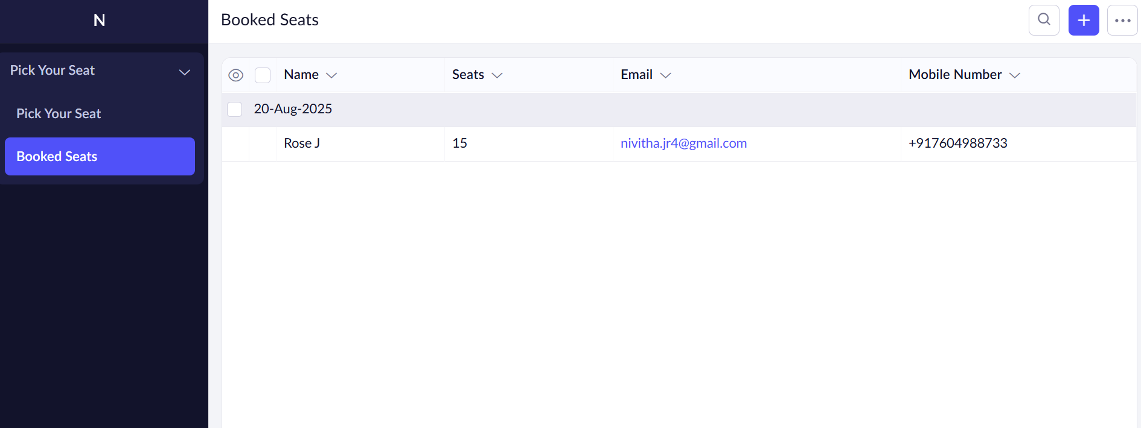

**Result**

Thus, a simple cloud-based application was successfully created and deployed using **Zoho Creator**, and it was provided as a **Software as a Service (SaaS)** model.